------------------ [30/8/24]---------------------------------  
  
@ResponseBody = This annotation is used to convert into json object notation.  
  
Whenever we want to learn the rest API package we have to give restapi application in the spring boot application.

@Controller , @responsebody annotation to work with the restAPI applications.  
  
@RestController = @Controller + @responsebody annotations.  
  
  
@GetMapping

The above annotation is used to handle the HTTP request.  
it is used to map incoming get requests to map the application…  
  
Here the rest API variable should be unique and it should be different.  
  
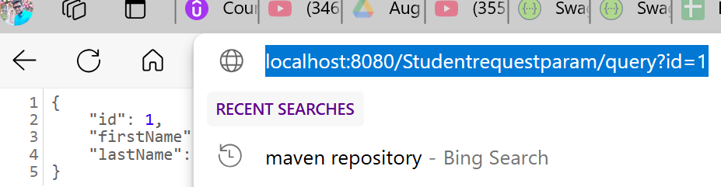  
  
  
@reuestparam  
  
This is the annotation used for request mapping for the data.  
--------------- [ 31/8/24] -------------------------------------------  
  
@PathVariable   
This annotation used for mapping the id for our method in the program,  
so with the help of this path variable we can map our values so it will return that value.  
  
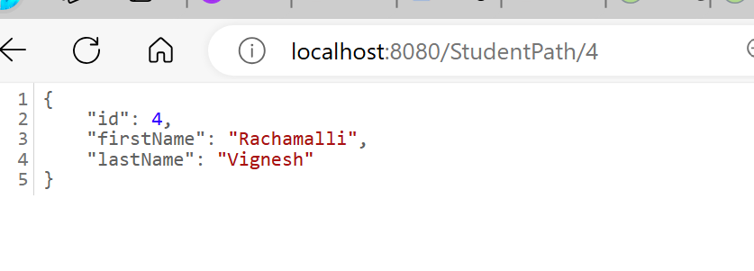  
  
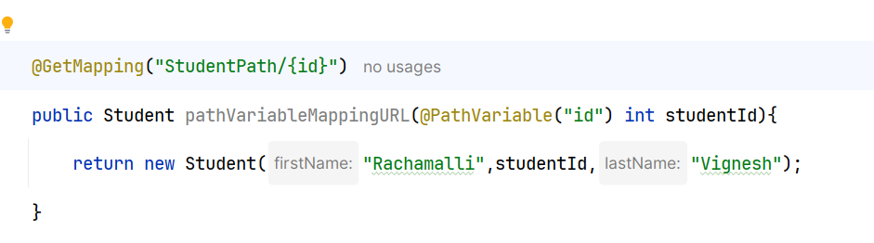  
  
  
------------------ This is another way of approach -----------  
  
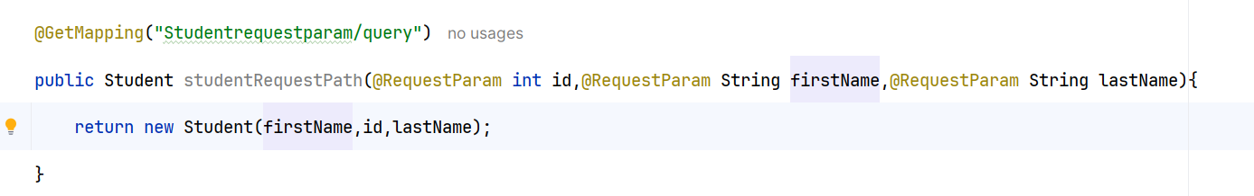  
  
  
🡪 The difference between @pathvariable and @getmapping is   
  
  
@pathvariable is used to bind uri template into method arguement and method body parameter what we have passed in the value in the url.